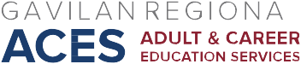

AB 104 Consortium Workshop Meeting
September 16, 2016
Agenda

- Updates
- TOPSpro/Data Collection Report/Common Intake – Presentation and Discussion – Dennis and Greg
- Pathways Visual
- Data Collection/Use of monies – General Discussion

Next Meeting: Oct. Friday, 7, 2016, HRC 101

